***Unisex Tom Ford Lost Cherry***

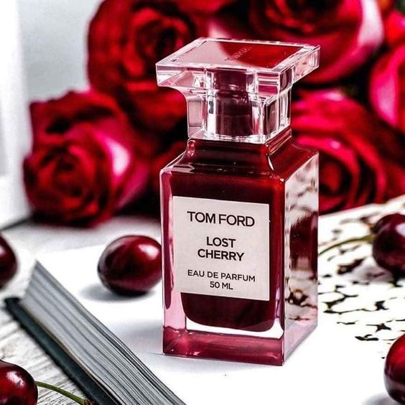

*True to the name "lost cherries" - Lost Cherry revolves around the note of cherry, a sweet, juicy fruit that often brings a sense of provocative, seductive and innocent in the art of perfumery. . If cherry is the main note, besides the support from red wine notes, almonds and tonka bean are the next outstanding scents. Those ingredients all bring a warm, passionate and sweet like candy, but with the ability of the Tom Ford family, it is a mature and bold candy, not immature or childish.*